Chaotic Electron transport in Semiconductor Superlattices

Christopher Bond

A817262

**Contents**

Abstract………………………………………………………………………………………………………………………………………..2

1. Introduction……………………………………………………………………………………………………………………………..3

2. Theory, Method and Analysis……………………………………………………………………………………………………4

2.1 Electron momentum and position………………………………………………………………………………………5

2.2 Scattering……………………………………………………………………………………………………………………….…11

2.3 Addition of magnetic field, effective mass………………………………………………………………………..15

2.4 Motion influenced by magnetic field……………………………………………………………………..………….16

2.5 Drift Velocity with magnetic influence………………………………………………………………………………21

3. Conclusions……………………………………………………………………………………………………………….……………23

4. References……………………………………………………………………………………………………………………………..24

5. Appendix………………………………………………………………………………………………………………………………..25

**Abstract**

When electrons propagate in a semiconductor superlattice, it causes the electrons undergo Bloch oscillation. When an external electric field is applied to the superlattice, the electrons scatter in such a manner that controlling the field and lattice period allows us to generate a very high frequency current. I will be investigating the mechanism behind this, and how drift velocity is affected by the external field. I will be looking at how the angle of the applied electric field affect the drift velocity of the electrons scattering within the superconductor, and will be writing a program to simulate charge transport under the influence of an external field. I intend to use the Kronig-Penney model of a quantum well as the basis for my study.

The period of oscillation in a superlattice without magnetic influence, using reasonable parameters of miniband width Δ = 20meV, lattice period d = 10nm and external field F = 106Vm-1, was determined to be 24.3 terahertz, proving that a superlattice is capable of outputting terahertz frequency electricity if externally stimulated with appropriate electric field.

A magnetic field was then introduced, and tilted to various angles, producing several electron motion profiles. It was found that the ratio is key to achieving resonance, as demonstrated in **figures 4.1** and **4.2**. It was also found that $θ=60°$ with r = 2, where $ω_{B}=r\hat{ω_{c}}$, yielded the best resonance and the highest achievable drift velocity, with the parameters of lattice spacing d = 9.3nm and energy gap $∆$ = 26.2meV. According to the graphs the maximal achievable drift velocity comes from $θ=60°$, but at an electric field such that r is not an integer.

1. **Introduction**

In this investigation, I will be looking at using a semiconductor superlattice to generate a charge-carrier frequency in the range of terahertz. Currently, frequencies in that range are too high to be conventionally generated electrically, and are too low to be generated optically. If it can be successfully generated, then it will have many applications, such as being applied inside computers, vastly increasing processing speed.

The aims of this project are to determine the most efficient angle at which to setup up the external electric field, and how the angle will affect the charge carriers within the material. It is also to investigate the trajectories and momentum of the electrons oscillating through the lattice, and model them accordingly.

Firstly we will be looking at the superlattice structure, and how the electrons undergo Bloch oscillation, and how the electrons will scatter based on scattering period $τ$. Using this the drift velocity $V_{d}$ can be modelled for the given parameters.

Then we will introduce a magnetic field in the x-z plane at angle $θ$ from the x-axis, and model the electron trajectories, investigating the chaotic motion and resonant motion based on the ratio of the period of Bloch oscillation to the cyclotron frequency of the system.

**2. Theory, Method and Analysis**

**2.1 Electron momentum and position.**

To begin, we will consider the Drude theory of conductivity. It describes the transport of electrons through a conductor and treats the electrons classically, similar to what we will be doing in this project.

We know from Ohms law that:

|  |  |  |
| --- | --- | --- |
|  | $$I=\frac{V}{R}$$ | (2.1.1) |

The current density $J$:

|  |  |  |
| --- | --- | --- |
|  | $$J=\frac{I}{A}$$ | (2.1.2) |

that electric field strength:

|  |  |  |
| --- | --- | --- |
|  | $$F=\frac{V}{L}$$ | (2.1.3) |

and that resistance of the wire

|  |  |  |
| --- | --- | --- |
|  | $$R=\frac{L}{Aσ}$$ | (2.1.4) |

where $σ$ is the conductivity of the wire, the inverse of resistivity. Combining the equations 2.1.1-2.1.4 yields

|  |  |  |
| --- | --- | --- |
|  | $$J=σF.$$ | (2.1.5) |

Within an electric field, the electron feels a force $-eF$, and a ‘friction’ force felt caused by collision with atoms in wire itself equal to $-m^{*}\frac{v}{τ}$, where $m^{*}$ is the effective mass of the electron based on the medium, $v$ is the velocity of the electron and introducing $τ$ as the collision time, the average time an electron travels before colliding with the next metal ion.

Newton’s law then states that

|  |  |  |
| --- | --- | --- |
|  | $$m^{*}\frac{dv}{dt}=-eF-m^{*}\frac{v}{τ}.$$ | (2.1.6) |

Within steady state diffusion, that is the average speed $\frac{dv}{dt}=0$, the equation becomes

|  |  |  |
| --- | --- | --- |
|  | $$v= -\frac{eτ}{m^{*}}F$$ | (2.1.7) |

We know that the charge can be written as $-Ne$, where $N$ is the number of electrons. Using equation 1.7, we can see that the charge travelling through unit area per unit time is

|  |  |  |
| --- | --- | --- |
|  | $$J= -Nev_{d}= -Ne\left(-\frac{eτ}{m^{*}}F\right)=\frac{Ne^{2}τ}{m^{*}}F=σ$$ |  |
|  | $$σ=\frac{Ne^{2}τ}{m^{*}}F$$ | (2.1.8) |

This can be analysed further, however we are not using an intrinsic material such a wire, but a more complicated alternating structure, which will use a similar model.

The basis for my investigation into the generation of terahertz begins with the Kronig-Penney model of a periodic potential. It describes a one-dimensional periodic potential, in the shape of a rectangular wave. Within these quantum wells, exists energy bands as described by quantum mechanics. We will be looking at the lowest energy band. The existence of the quantum wells and miniband structure is due to the varying chemical potential of the different layers, and it is due to the relatively large period between repeating layers, that the bands are small enough to be called minibands, because a larger width *d* means a smaller slot in reciprocal space.

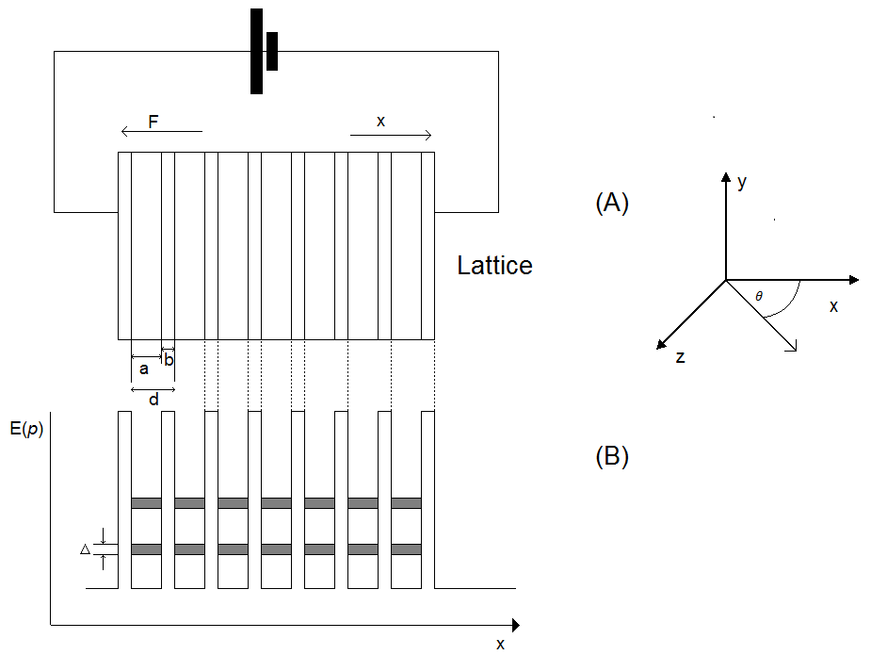

**Figure 2.1.1** – A semiconductor superlattice in a circuit and its corresponding quantum wells. The top portion labelled (A) shows the circuit, with the alternating layers of superlattice material, and the lower portion (B) represents the corresponding quantum wells, with the gray sections being the energy bands within the wells. The lowest one is labelled with $Δ$, and it is this band that will be analysed.

In the presence of an externally applied electric field, the band structure shifts into a diagonal, as in ***figure 2.1.2***. It is this situation that I will be studying.

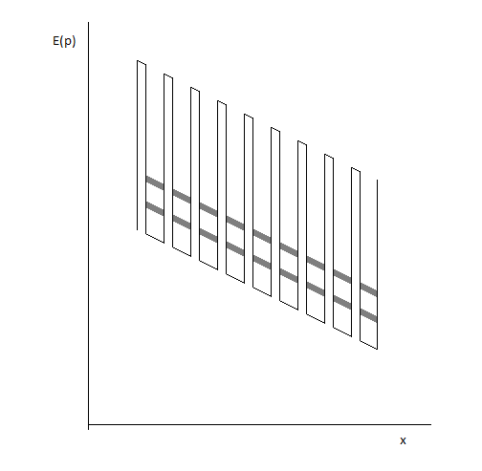

**Figure 2.1.2**

The mini-band structure in the presence of an external electric field.

I will be treating the work semiclassically, and the semiclassical Hamiltonian states that

|  |  |  |
| --- | --- | --- |
|  | $$H\left(x,p\right)=\left(\frac{p^{2}}{2m}\right)-eFx$$ | (2.1.9) |

where $\frac{p^{2}}{2m}$ is the electron momentum and $-efx$ is the influence of an applied electric field. To determine how the electron motion within the superlattice changes in time t, the semiclassical Hamiltonian can be integrated with respect to time for both momentum and external electric field components.

Integrating with the initial conditions $x_{t=0} = x_{0}$ and ${ ρ}_{t=0}= ρ_{0}$:

|  |  |  |
| --- | --- | --- |
|  | $$ẋ=\frac{∂x}{∂t}= \frac{∂H}{∂ρ}=\frac{ρ}{m}$$ | (2.1.9) |
|  | $$ρ ̇=\frac{∂ρ}{∂t}=\frac{∂H}{∂x}= -eF$$ | (2.1.10) |

|  |  |  |
| --- | --- | --- |
|  |  | (2.1.11) |
|  |  |  |

|  |  |  |
| --- | --- | --- |
|  |  | (2.1.12) |

Thus we can see that the momentum $ρ$ has a linear dependency on time t, whereas position x has a quadratic dependence.

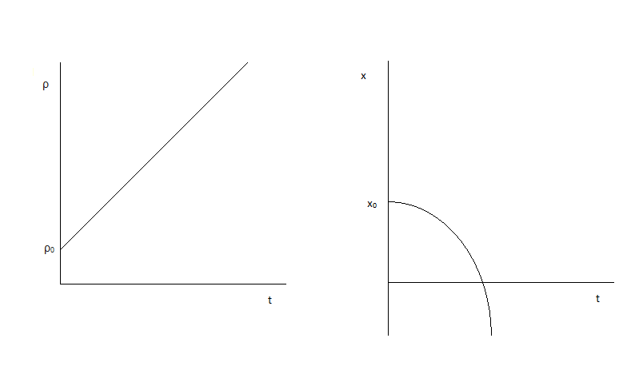

**Figure 2.1.3** The dependence of position and momentum on time t.

To determine the nature of the minibands, we will take the Tight-Binding model, which allows us to calculate the energy range of an electron travelling through the medium [1][2]:

|  |  |  |
| --- | --- | --- |
|  |  | (2.1.13) |

Where Δ is the width of the lowest miniband, $ρ$ is the electron momentum, d is the lattice period and $ℏ$ is the reduced Planck constant. Note that the form of this is that of a cosine wave, which means there is an oscillation. This is known as Bloch oscillation [3][11], whereby an electron oscillates back and forth within the lattice period, shown in ***Figure 2.1***.

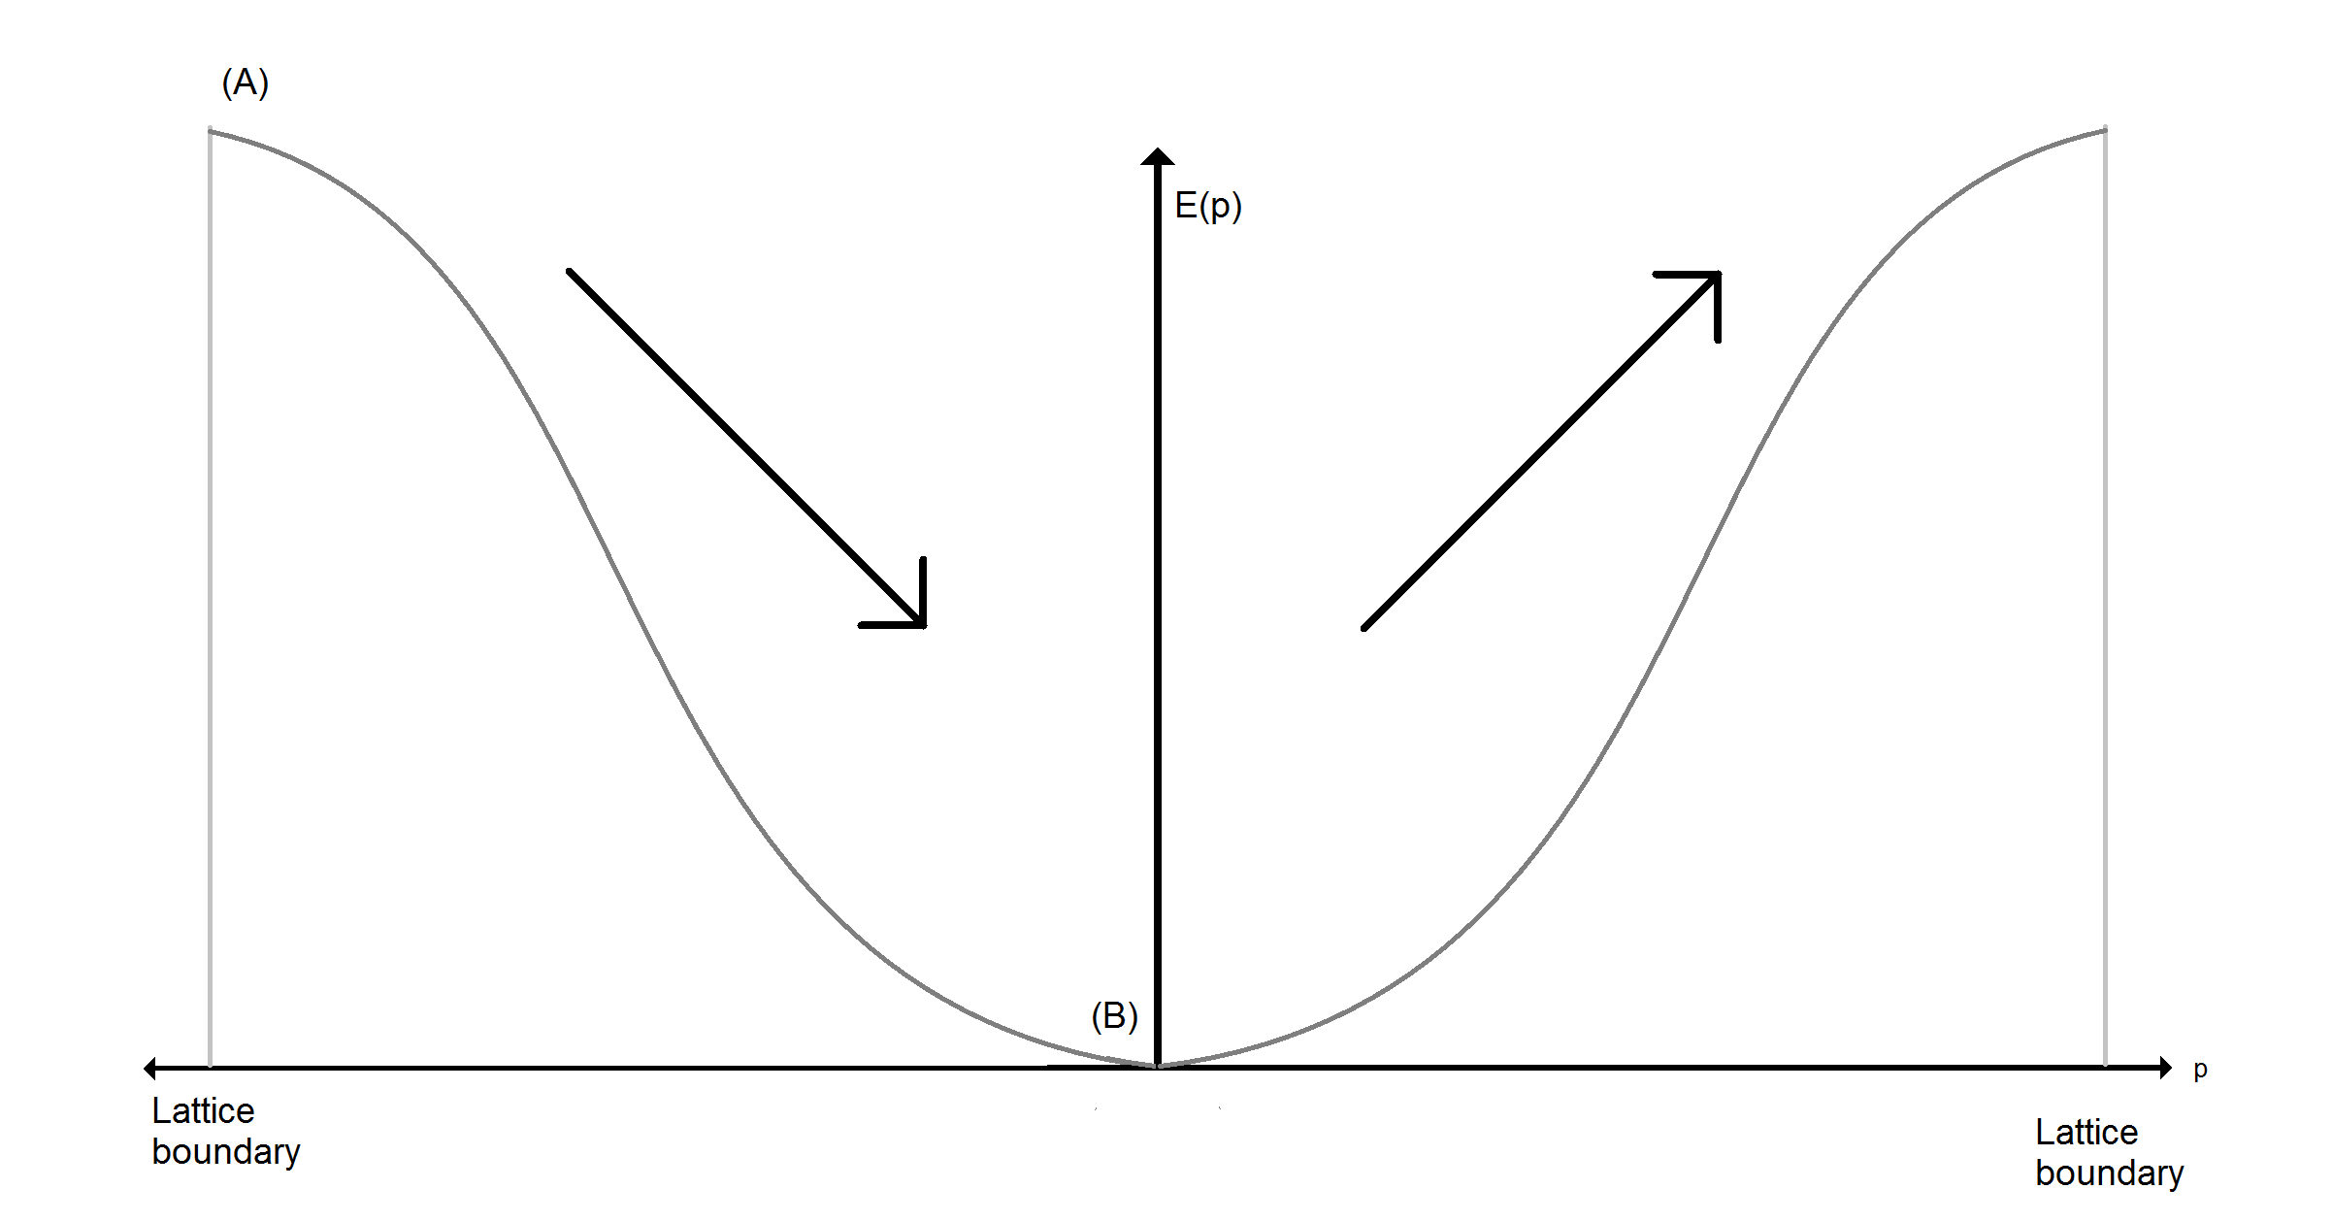

**Figure 2.1.4** How electrons oscillation within the first brillouin zone. This figure illustrates the dispersion relation $E\left(ρ\right)=\frac{Δ}{2}(1-\cos\left(\frac{ρd}{ℏ}\right))$, oscillating from point (A) down to (B), then back up to (A), oscillating as the system repeats as the momentum increases up to the lattice boundary, where it decreases again.

Now that this method of oscillation has been established, we can determine how it varies in time t by inserting it into the semiclassical Hamiltonian as the momentum component.

|  |  |  |
| --- | --- | --- |
|  | $$H\left(x,ρ\right)=\left(\frac{Δ}{2}(1-cos⁡(\frac{ρd}{ℏ})\right)-eFx$$ | (2.1.14) |

Once again we take the initial conditions x(0) = x0 and ρ(0)= ρ0:

|  |  |  |
| --- | --- | --- |
|  |  | (2.1.15) |
|  |  | (2.1.16) |

rom before se the inital ries in time t by inserting it into the semiclassical Hamiltonian as the momentum component.

Substituting equation (2.11)

$$\int_{x_{0}}^{x}{dx= \int_{0}^{t}{\frac{Δd}{2ℏ}sin⁡(\frac{ρ_{0}d}{ℏ}+\frac{eFd}{ℏ}t) dt}}$$

|  |  |  |
| --- | --- | --- |
|  | $$x_{t}-x_{0}= -\frac{Δ}{2}\frac{1}{eF}\left(\cos\left(\frac{d}{ℏ}\left(ρ_{0}+eFt\right)\right)-\cos\left(\frac{ρ_{0}d}{ℏ}\right)\right)$$ | (2.1.17) |

We can discard the $x_{0}$ and $\cos\left(\frac{ρ_{0}d}{ℏ}\right)$ as they are constants (equal to zero) and do not vary with time, which leaves us with:

|  |  |  |
| --- | --- | --- |
|  | $$x_{t}=\left(-\frac{Δ}{2}\frac{1}{eF}\right)cos⁡(\frac{eFd}{ℏ}t+\frac{ρ_{0}d}{ℏ})$$ | (2.1.18) |

Which is in the general wave form of $x_{t}=Acos(ωt+ψ)$ and can be graphed. We will be using Euler’s method to numerically solve integral, and the code can be seen in Appendix B.

**Figure 2.1.5** – A graph showing the numerically calculated position (using eulers method with eqn 2.1.16) with t against the analytically calculated position (simply plotting eqn 2.1.18)

Taking some ideal coefficients: miniband width Δ = 20meV, lattice period d = 10nm and external field F = 106Vm-1, we can determine that the period of Bloch oscillation.

***Figure 2.1.6*** A graph showing how the position varies with time t. The electron oscillates between the lattice boundaries. It was graphed by implementing eqn.(2.18) in excel.[12]

The period is determined to be 4.12 x10-14s thus having a frequency of 2.43 x1013Hz, or 24.3 terahertz.

**2.2 Scattering**

Scattering in a periodic potential is key to the transport of charge. If there is no scattering, then the electrons will simply oscillate within their lattice period at frequency $ω=\frac{eFd}{ℏ}$ and no charge will be transported. Collisions are required to pass on the energy, and so allow charge to flow. Therefore flow is governed by the scattering time $τ$, which is the time between collisions.

There are two types of scattering. Elastic scattering is where kinetic energy is conserved, but the particle direction is changed. Inelastic scattering is where kinetic energy is not conserved, and it is this type of scattering that I will be investigating.

Taking N(t) as the number of electrons left unscattered after time t. So in time t + dt,

|  |  |  |
| --- | --- | --- |
|  | $$N\left(t+dt\right)=N\left(t\right)-\frac{N\left(t\right)dt}{τ}$$ | (2.2.1) |

Which can be rearranged into

$$\frac{N\left(t+dt\right)-N\left(t\right)}{dt}= -\frac{N\left(t\right)}{τ}$$

This is the general form of a differential equation, thus

$$\frac{dN\left(t\right)}{N(t)}= -\frac{dt}{τ}$$

$$\int_{N_{0}}^{N}{\frac{1}{N\left(t\right)}dN\left(t\right)=\int_{0}^{t}{-\frac{1}{τ}dt}}$$

$$\ln\left(N\left(t\right)\right)-\ln\left(N_{0}\right)=-\frac{t}{τ}$$

$$\ln\left(\frac{N\left(t\right)}{N_{0}}\right)= -\frac{t}{τ}$$

|  |  |  |
| --- | --- | --- |
|  | $$\frac{N\left(t\right)}{N_{0}}=e^{-\frac{t}{τ}}$$ | (2.2.2) |

which is the proportion of unscattered electrons after time t with scattering time $τ$.

Therefore the probability of scatter occurring in time t can be determined:

$$p\left(t\right)dt=\frac{N\left(t\right)dt}{τ}*\frac{1}{N_{0}}$$

(dividing the number of electrons that scatter in time interval dt by N0 electrons. Therefore from above:

|  |  |  |
| --- | --- | --- |
|  | $$p\left(t\right)dt=\frac{e^{-\frac{t}{τ}}}{τ}dt$$ | (2.2.3) |

Now that the probability of scattering has been determined, the overall drift velocity can be calculated. The drift velocity is the charge flow from the external electric field, and is the combination of the scattering probability and the bloch oscillation. Thus we can define the drift velocity Vd:

|  |  |  |
| --- | --- | --- |
|  |  | (2.2.4) |
|  |  |  |
|  | $$V_{d}=\frac{1}{τ}\frac{Δd}{2ℏ}\int_{0}^{∞}{\sin\left(\frac{efd}{ℏ}t\right)e^{-\frac{t}{τ}}}$$ | (2.2.5) |

|  |  |  |
| --- | --- | --- |
|  |  |  |

Which, through integration by parts, results in:

$$V_{d}=\frac{∆d}{2ℏ}\left(\frac{τ\left(\frac{eFd}{ℏ}\right)}{1+{\left(τ\left(\frac{eFd}{ℏ}\right)\right)}^{2}}\right)$$

The drift velocity here can be also be written

|  |  |  |
| --- | --- | --- |
|  | $$v_{d}=\frac{∆d}{2ℏ}(\frac{τω_{b}}{1+{\left(τω_{b}\right)}^{2}})$$ | (2.2.6) |

Where $ω_{b}=\frac{eFd}{ℏ}$ is the frequency of Bloch oscillation. This method of taking scattering time and velocity in the $x$ position is known as the Esaki-Tsu method.[7]

The drift velocity can now be graphed, and will be done by applying Euler’s method (see appendix B for the code) to the

$$V_{d}=\frac{1}{τ}\frac{Δd}{2ℏ}\int_{0}^{∞}{\sin\left(\frac{efd}{ℏ}t\right)e^{-\frac{t}{τ}}}$$

By using a step size of

Since the function of $y=\frac{x}{1+x^{2}}$ has a local maxima at x = 1, we know that the drift velocity has local maxima at $τω_{b}=1$, or $τ\frac{eFd}{ℏ}=1$, which can be rearranged to find the critical field strength Fc:

***Figure 2.2.1***- A visual representation of how the drift velocity varies with applied electric field strength, and how the scatter time affect the point at which the maximum drift velocity is achieved. These curves are known as Esaki-Tsu curves, from Leo Esaki and Raphael Tsu or pioneered superlattice analysis.

|  |  |  |
| --- | --- | --- |
|  | $$F_{c}=\frac{ℏ}{edτ}$$ | (2.2.7) |

At this point, the drift velocity is effectively $V_{d}=\frac{∆d}{2ℏ}×(1)$, thus $\frac{∆d}{2ℏ}$ at critical field strength.

Thus for the respective scattering times, and with miniband width Δ = 20meV and lattice period $d = 10nm$, we can determine the Fc, the critical field strengths. For $τ$ = 100fs, Fc = 4.14106Vm-1; = 200fs, Fc = 2.07106Vm-1; and for = 300fs, Fc = 1.38106Vm-1.

From ***figure 3.1*** and the calculations we can see that the drift velocity of the electrons can be increased by increasing the lattice spacing $d$, or increasing the energy gap within the material. Since these are two things which cannot be selectively changed without changing the physical structure of the superlattice. Thus we can take from that that within a superlattice, there is a fixed maximum drift velocity which cannot be exceeded, based on the chemical composition and engineering of the lattice. The energy gap $Δ$ can be directly controlled however, and so custom superlattices can be constructed for desired values of $V_{d}$, although getting material compositions of specific energy gap can be difficult. Changing the lattice spacing $d$ would not have much of effect, because the drift velocity becomes:

$$V_{d}=\frac{\frac{Δ}{2ℏ}\left(\frac{τeF}{ℏ}d^{2}\right)}{1+\left(\frac{τ^{2}e^{2}F^{2}}{ℏ^{2}}d^{2}\right)}$$

This is effectively the same as:

$$V_{d}=\frac{ax^{2}}{1+bx^{2}}$$

Which has local maxima based on the relationship between $a$ and $b$, which in itself is again based on the energy gap $Δ$.

**Introducing an external magnetic field to induce chaotic electron trajectories**

**2.3 Effective mass of an electron**

An electron experiencing Bloch oscillation within a lattice does not quite react to forces they way it might be expected to, it acts as though it has a much smaller mass. The calculation of this effective mass allows us to assume the electron is travelling through an intrinsic material rather than a material with a varying conduction band.

Quantum mechanically, if an electron is ‘free’ within a lattice, than we can take $ρ=ℏk$, where $ρ$ the electron momentum is and $k$ is the electron wave vector taken from the dispersion relation. In the case I am looking at, the dispersion relation is $E\left(ρ\right)=\frac{∆}{2}(1-\cos\left(\frac{ρd}{ℏ}\right))$. Thus from $ρ=ℏk$ we can take the dispersion relation $E(ρ)$ to be $E\left(k\right)=\frac{∆}{2}\left(1-\cos\left(kd\right)\right)$. The energy of an electron at the new point $k$ can be described by $E(k)=E_{0}+\frac{ℏ^{2}}{2m^{*}}{\left(k-k_{1}\right)}^{2}$, and since we start from rest $(k=0)$, we can take $E\left(k\right)=E_{0}+\frac{ℏ^{2}k^{2}}{2m^{*}}$, where $m^{*}$ is what we call the effective mass of the electron. The effective mass is defined as the mass that the electron appears to have, being in a state of Bloch oscillation, but actually does not have. $E(k)$ in this form is able to be integrated to find how it varies in $k$– space.

|  |  |  |
| --- | --- | --- |
|  | $$E\left(k\right)-E_{0}=\frac{ℏ^{2}k^{2}}{2m^{*}}$$ | (2.3.1) |

$$\frac{dE}{dk}=\frac{ℏ^{2}k}{m^{*}}$$

$$\frac{d^{2}E}{dk^{2}}=\frac{ℏ^{2}}{m^{*}}$$

Finally we can see that the effective mass $m^{*}$ is

|  |  |  |
| --- | --- | --- |
|  | $$\frac{1}{m^{*}}=\frac{1}{ℏ^{2}}\frac{d^{2}E}{dk^{2}}$$ | (2.3.2) |

For the dispersion relation used in this model, $E\left(k\right)=\frac{∆}{2}(1-\cos\left(kd\right))$, we take the second derivative:

$$\frac{dE}{dk}=\frac{∆d}{2}sin⁡(kd)$$

$$\frac{d^{2}E}{dk^{2}}=\frac{∆d^{2}}{2}cos⁡(kd)$$

Inputting into eqn. 2.3.2:

|  |  |  |
| --- | --- | --- |
|  | $$\frac{1}{m^{*}}=\frac{1}{ℏ^{2}}\frac{∆d^{2}}{2}\cos\left(kd\right)$$ | (2.3.3) |

From rest, at the bottom of the dispersion curve, we take $k=0$, and using lattice spacing d = 9.3nm and energy gap $∆$ = 26.2meV = $4.192×{10}^{-21}$ j, we get the $m^{*}=6.103×{10}^{-32}$ kg, or $0.067m_{e}$, where $m_{e}=9.11×{10}^{-31}$ is the rest mass of an electron. These values of $∆$ and $d$ were taken from a previous investigative paper on the subject of chaotic electron transport in superlattices.[6]

**2.4 Electrons influenced by both an electric and magnetic field**

Now we can begin to examine how the electron motion will be affected by an external applied magnetic field of strength B Teslas, applied at angle $θ$ from the x-direction in the x-z plane, thus B will have components

|  |  |  |
| --- | --- | --- |
|  | $$\vec{B}=\left(\cos{θ},0,sinθ\right)$$ | (2.4.1) |
|  |  |  |

To begin we can modify the semi-classical Hamiltonian used earlier. With the magnetic field as well as the electric field, the electron will be experiencing a Lorentz force and thus will have x, y and z components. We know that the dispersion relation in the x-direction is given by

$$E\left(p_{x}\right)=\frac{Δ}{2}\left(1-\cos\left(\frac{ρ_{x}d}{ℏ}\right)\right).$$

We can take the $y$ and $z$ components classically, with the calculated effective mass in place of the actual electron mass. This the new Hamiltonian becomes

|  |  |  |
| --- | --- | --- |
|  | $$H\left(ρ_{x},ρ_{y},ρ_{z}\right)=\frac{Δ}{2}(1-\cos\left(\frac{ρ_{x}d}{ℏ}\right))+\frac{ρ_{y}^{2}}{2m^{*}}+\frac{ρ_{z}^{2}}{2m^{*}}-eFx$$ | (2.4.2) |

The position and thus velocity can be determined from this new modified Hamiltonian, calculated as

|  |  |  |
| --- | --- | --- |
|  | $$\dot{x}=\frac{∂H}{∂ρ_{x}}=\frac{∂x}{∂t}=\frac{Δd}{2ℏ}(\sin\left(\frac{ρ_{x}d}{ℏ}\right))$$ | (2.4.3) |
|  | $$\dot{y}=\frac{∂H}{∂ρ_{y}}=\frac{∂y}{∂t}=\frac{ρ_{y}}{m^{*}}$$ | (2.4.4) |
|  | $$\dot{z}=\frac{∂H}{∂ρ_{z}}=\frac{∂z}{∂t}=\frac{ρ_{z}}{m^{*}}$$ | (2.4.5) |

We can take the Lorentz force felt by the electron as being the increase in the momentum components, thus

|  |  |  |
| --- | --- | --- |
|  | $$\frac{∂p}{∂t}=F= -e\left(F+\left(∇_{ρ}E×B\right)\right)$$ | (2.4.6) |

where $∇_{ρ}E=\frac{∂\left(E\right)}{∂x},\frac{∂\left(E\right)}{∂y},\frac{∂\left(E\right)}{∂z}$.

Thus $∇_{ρ}E$ becomes

|  |  |  |
| --- | --- | --- |
|  | $$∇_{ρ}E=\left(\frac{Δd}{2ℏ}\sin\left(\frac{ρ_{x}d}{ℏ}\right), \frac{ρ_{y}}{m^{*}}, \frac{ρ_{z}}{m^{*}}\right)$$ | (2.4.7) |

Taking the cross product with $B=(cosθ,0,sinθ)$, and completing the equation for the Lorentz force, we acquire the expressions for electron momentum:

|  |  |  |
| --- | --- | --- |
|  | $$\dot{ρ_{x}}=\frac{∂H}{∂x}= \frac{∂ρ_{x}}{∂t}=eF-\frac{ρ_{y}}{m^{*}}\sin\left(θ\right)$$ | (2.4.8) |
|  | $$\dot{ρ_{y}}=\frac{∂H}{∂y}=\frac{∂ρ_{y}}{∂t}= e\frac{Δd}{2ℏ}\sin\left(\frac{ρ_{x}d}{ℏ}\right)Bsin\left(θ\right)-e\frac{ρ_{z}}{m^{*}}Bcos(θ)$$ | (2.4.9) |
|  | $$\dot{ρ_{z}}=\frac{∂H}{∂z}=\frac{∂ρ_{z}}{∂t}=e\frac{ρ_{y}}{m^{*}}Bcos(θ)$$ | (2.4.10) |

We can substitute the formulae for Bloch oscillations $W_{B}$ and the cyclotron frequency ${ W}_{C}$, where

|  |  |  |
| --- | --- | --- |
|  | $$ω_{B}=\frac{eFd}{ℏ}$$ | (2.4.11) |
|  | $$\hat{ω_{C}}=\frac{eB}{m^{*}}cos⁡(θ)$$ | (2.4.12) |

Thus the expressions for momentum become

|  |  |  |
| --- | --- | --- |
|  | $$\dot{ρ_{x}}=eF- ρ_{y}\hat{ω_{c}}tan⁡(θ)$$ | (2.4.13) |
|  | $$\dot{ρ_{y}}=\frac{Δdm^{*}\hat{ω_{c}}}{2ℏ}\sin\left(\frac{ρ_{x}d}{ℏ}\right)\tan\left(θ\right)-\hat{ω_{c}}ρ_{z}$$ | (2.4.14) |
|  | $$\dot{ρ_{z}}=\hat{ω_{c}}ρ_{y}$$ | (2.4.15) |

The dependence of $\dot{ρ_{x}}$ on $ρ_{y}$ can be displayed more simply by taking initial conditions for $ρ_{z}$, allowing the $\dot{x}$ to be displayed as dependant only on $ρ_{z}$: $$\int_{0}^{t}{\dot{ρ_{z}}}dt= \int_{0}^{t}{(\hat{ω_{c}}ρ_{y})dt}$$

$$ρ_{z}-ρ_{z\left(t=0\right)}=\hat{ω_{c}}ρ_{y}t$$

|  |  |  |
| --- | --- | --- |
|  | $$ρ_{y}=\frac{ρ_{z}}{\hat{ω_{c}}t}-\frac{ρ_{z\left(t=0\right)}}{\hat{ω_{c}}t}$$ | (2.4.16) |

And ${ ρ}_{x}$: $$\int_{0}^{t}{\dot{ρ_{x}}dt}=\int_{0}^{t}{(eF-ρ_{y}\hat{ω_{c}}\tan\left(θ\right))dt}$$

$$ρ_{x}-ρ_{x\left(t=0\right)}=eFt- ρ_{y}{(ω}_{c}t)tan⁡(θ)$$

$$ρ_{x}=eFt-ρ_{y}{(ω}_{c}t)tan\left(θ\right)+ ρ_{x(t=0)}$$

|  |  |  |
| --- | --- | --- |
|  | $$ρ_{x}=eFt-\left(ρ_{z}-ρ_{z\left(t=0\right)}\right)\tan\left(θ\right)+ ρ_{x(t=0)}$$ | (2.4.17) |

Thus the new position expressions become:

|  |  |  |
| --- | --- | --- |
|  | $$\dot{x}=\frac{Δd}{2ℏ}sin⁡(\frac{d}{ℏ}\left(eFt-ρ_{z}\tan\left(θ\right)+ρ_{z\left(t=0\right)}\tan\left(θ\right)+ ρ_{x\left(t=0\right)}\right))$$ | (2.4.18) |
|  | $$\dot{y}=\frac{ρ_{z}}{m^{*}ω_{c}}$$ | (2.4.19) |

|  |  |  |
| --- | --- | --- |
|  |  | (2.4.20) |

The equations for ${\dot{ρ}}_{y}$ and ${\dot{ρ}}_{z}$ can be rearranged to take the form a second-order non-homogenous differential equation

$${\ddot{ρ}}_{z}=\frac{∂}{∂t}\left({\dot{ρ}}_{z}\right)=ω_{c}\frac{∂}{∂t}\left(ρ_{y}\right)=ω_{c}{\dot{ρ}}_{y}=\frac{Δdm^{*}{\hat{ω_{c}}}^{2}}{2ℏ}\tan\left(θ\right)\sin\left(\frac{ρ_{x}d}{ℏ}\right)-{\hat{ω_{c}}}^{2}ρ_{z}$$

$$\ddot{ρ_{z}}+{\hat{ω_{c}}}^{2}ρ_{z}=\frac{Δdm^{*}{\hat{ω_{c}}}^{2}\tan\left(θ\right)}{2ℏ}sin⁡(\frac{d}{ℏ}\left(eft- ρ_{z}tan\left(θ\right)+ρ_{z\left(t=o\right)}+ρ_{x\left(t=0\right)}\right))$$

$$\ddot{ρ_{z}}+{\hat{ω_{c}}}^{2}ρ_{z}=\frac{Δdm^{*}{\hat{ω_{c}}}^{2}\tan\left(θ\right)}{2ℏ} sin⁡(ω_{B}t-\frac{d}{ℏ}{\tan\left(θ\right)ρ}_{z}+ρ_{z\left(t=0\right)}\tan\left(θ\right)+ρ_{x\left(t=0\right)})$$

|  |  |  |
| --- | --- | --- |
|  | $$\ddot{ρ_{z}}+{\hat{ω_{c}}}^{2}ρ_{z}=Csin(ω_{B}t-Kρ_{z}+ϕ)$$ | (2.4.21) |

Where

$$C=\frac{Δdm^{*}{\hat{ω_{c}}}^{2}\tan\left(θ\right)}{2ℏ}$$

$$K=\frac{d}{ℏ}tan⁡(θ)$$

And the phase shift due to initial conditions

$$ϕ=\frac{d}{ℏ}\left(ρ_{z\left(t=0\right)}\tan\left(θ\right)+ρ_{x\left(t=0\right)}\right).$$

The equation 2.4.21 is also in the form of an externally-driven one-dimensional harmonic oscillator. We know that in a general one-dimensional harmonic oscillator,

$$a\ddot{x}+b\dot{x}+cx=f\left(x\right),$$

B corresponds to the damping constant of the system, and C corresponds to the natural frequency of the oscillator. In the case of our oscillator, we have $b=0$ and thus no damping of the system, and $c= {\hat{ω_{c}}}^{2}$, meaning that the electron has natural frequency $\hat{{ ω}_{c}}=\frac{eB}{m^{*}}cos⁡(θ)$. The harmonic oscillator form also indicates that resonance can be achieved with the correct parameters.

With the expressions for $\dot{p_{x}},\dot{p_{y}},\dot{p_{z}},\dot{x},\dot{y}$ and $\dot{z}$, and assuming that

$$ρ_{x(t=0)}=ρ_{y(t=0)}=ρ_{z(t=0)}=x_{t=0}=y_{t=0}=z_{t=0}=0$$

We can numerically solve for the position in the x-z plane.

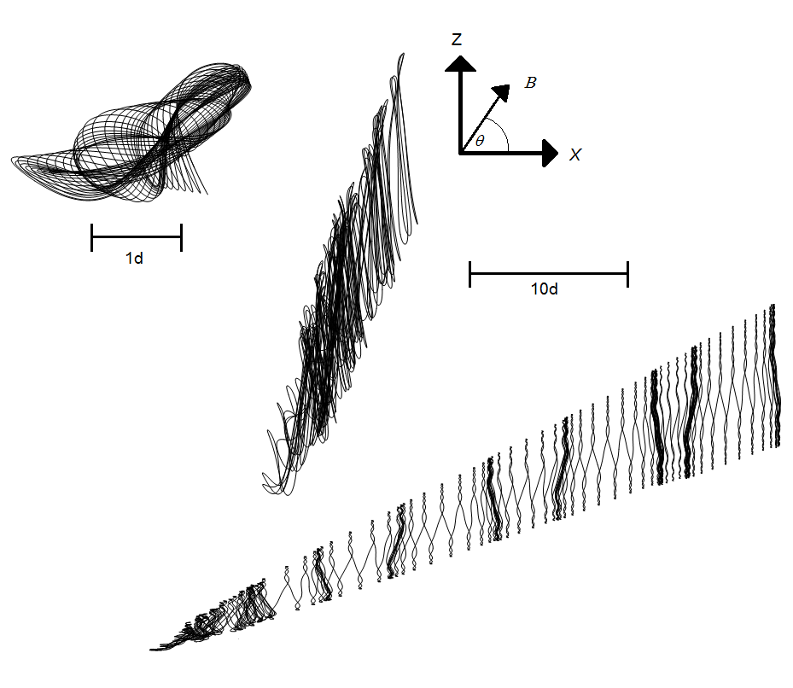

***Figure 2.4.1*** – Figures of the trajectories of the electron taken in the X-Z plane, with magnetic field B = 15T being applied at angle $θ$. (a) $θ$ = 30 $°$, $F = 1.54$ X ${10}^{6}$; (b) $θ=45°$, $F=1.75$ X ${10}^{6}$; (c) $θ=60°$, $F=2.77$ X ${10}^{6}$. The axes indicated show the directions of X, Z and $θ$. The left bar shows the scale of (a) $θ=30°$, and the right bar shows the scale of (b) $θ=45°$ and (c) $θ=60°$; where d = 9.3nm is the superlattice space constant.

a)

b)

Figure () shows that the under the influence of an external electric field and a magnetic field applied at angle $θ$, the electrons oscillate in a

c)

Figure 4.1 shows that there is a connection between the angle and whether or not the electron trajectory is chaotic or more ordered. This is due to the syncing of the systems natural frequency (cyclotron frequency) $\hat{ω_{c}}$ and the Bloch frequency $ω_{B}$. When the parameters are such that $ω_{B}=r\hat{ω_{c}}$, where r is an integer, the electron oscillation becomes much more regular and travels further through the lattice, as illustrated in the simulation of ***figure 2.4.1(c)***.[5][6]

Starting with $ω_{B}=\frac{eFd}{ℏ}$ and $\hat{{ ω}_{c}}=\frac{eB}{m^{*}}cos⁡(θ)$,

$$ω_{B}=r\hat{ω_{c}}$$

$$\frac{F}{B}=r\frac{ℏ}{dm^{*}}\cos\left(θ\right)$$

Or in the case of the parameters used:

|  |  |  |
| --- | --- | --- |
|  | $$F=2774625.864 rcos(θ)$$ | (2.4.22) |

The magnetic field selected was taken as $B=15T$ instead of $2T$ as used in [6], due to being unable to achieve any non-Esaki-Tsu peaks.

This was used to determine the necessary value of r, and so in ***figure 4.1 (c)***, r=2. For $θ=60°$, I was unable to achieve anything resembling a resonant trajectory for r=1, and so the next value of r=2 was used instead as it generated a much better image.

**2.5 Drift Velocity with magnetic influence**

We have seen that the electron behave differently based on the ratio of $ω_{B}$/ $\hat{ω_{c}}$, which can be varied within a fixed magnetic field by changing the electric field strength $F$ or the angle $θ$.

We can use a previously derived equation for the drift velocity, and substitute the velocity in the x direction.

|  |  |  |
| --- | --- | --- |
|  | $$V_{d}=\frac{1}{τ}\frac{Δd}{2ℏ}\int_{0}^{∞}{\dot{x}e^{-\frac{t}{τ}}}$$ | (2.5.1) |
|  |  |  |
|  | $$V_{d}=\frac{1}{τ}\frac{Δd}{2ℏ}\int_{0}^{∞}{\dot{sin⁡(\frac{d}{ℏ}\left(eFt-ρ_{z}\tan\left(θ\right)+ρ_{z\left(t=0\right)}\tan\left(θ\right)+ ρ_{x\left(t=0\right)}\right))}e^{-\frac{t}{τ}}}$$ | (2.5.2) |

Starting from $ρ_{x(t=0)}=ρ_{y(t=0)}=ρ_{z(t=0)}=x_{t=0}=y_{t=0}=z_{t=0}=0$,

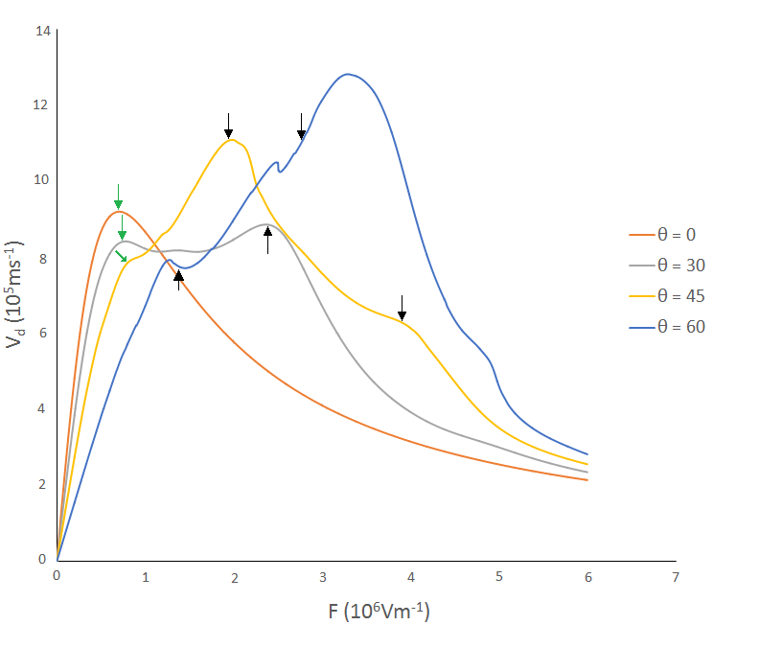

**Figure 4.2** – A plot of the drift velocities $V_{d}$ (eqn 2.5.3) against electric field strength $F$, with the magnetic field $B=15$ T oriented at angles 0 $°$, 30 $°$, 45 $°$ and 60 $°$. The arrows indicate the points at which $\frac{ω_{B}}{\hat{ω_{c}}}=r$ is an integer, with the value of r labelled. The green arrow indicate the Esaki-Tsu peaks.

r = 1

r = 1

r = 1

r = 2

r = 2

|  |  |  |
| --- | --- | --- |
|  | $$V_{d}=\frac{1}{τ}\frac{Δd}{2ℏ}\int_{0}^{∞}{\dot{sin⁡(\frac{d}{ℏ}\left(eFt-ρ_{z}\tan\left(θ\right)\right)}{)e}^{-\frac{t}{τ}}}$$ | (2.5.3) |

Figure 4.2 shows the drift velocities against increasing electric field strength for various angles. We can see that at 30 $°$, the peak drift velocity corresponds with the chaos assisted resonance peak for $r=1$, at $F=1961956.764 Vm^{-1}$, and for 45 $°$ the maximal peak drift velocity also corresponds to the chaos assisted resonance peak r=1, with $F=2402896.484$. As stated earlier, I was unable to acquire a clean trajectory for r=1 at $θ=60°$, the result was always chaotic. For $θ=0$, we can see a normal representation of an Esaki-Tsu curve, as shown earlier in figure **2.2**. As we increase the angle, we can note the remnants of an Esaki-Tsu peaks, growing less pronounced angle increases, becoming almost unrecognisable as $θ=60$.

The relation of the maximal drift velocities at $θ=45°$ and $θ=30°$ to the integer values of $r$ suggest that the by altering the electric field strength, magnetic field strength and magnetic field angle $θ$, it might be possible to achieve a specific drifty velocity. We can see that for resonant values of r, the electrons move faster, and with a fixed scattering time we can take that the period of Bloch oscillations is also wider, proved by eqn 2.1.18 and eqn. 2.4.11.

**3. Conclusion**

The use of a semiconductor superlattice proves to potentially be a good source of terahertz level current, as in section 2.1 the achieved period of Bloch oscillation was determined, for the parameters at the end of section 2.1, to be approximately 4.12 x10-14s, producing a frequency of 24.7 terahertz.

We can conclude from the Esaki-Tsu graph (figure **2.2.1**) and its calculations that for no external magnetic field, the maximum achievable drift velocity within a superlattice is not governed by its lattice spacing, nor can be increased by changing the electric field strength, but can be increased by changing the energy gap. Since this requires construction of a new superlattice, this means that within a superlattice there will always be a fixed maximum drift velocity.

When a tilted magnetic field is applied to the superlattice, the electrons experience a Lorentz force which, at integer values of r for which $ω_{B}=r\hat{ω_{c}}$, generate higher drift velocity due to the resonance between the period of Bloch oscillation and the systems natural cyclotron frequency. However for $θ=60°$, the $r=1$ electric field produced a more chaotic trajectory. While $θ=45°$ yields a more stable orbit, $θ=60°$ yields a higher drift velocity for the higher electric field strengths. The wide variation in the drift velocity curves suggests that it may be possible to custom build a superlattice to suit a specific desired value of drift velocity ${ V}_{d}$.

In conclusion, the use of a semiconductor superlattice as a source of terahertz level current is very effective, although with the considerable magnetic and electric field strengths required, it may be impractical to attempt to generate such electricity, as the high electric field strength would necessitate a faraday cage around the superlattice, and the high magnetic field strength might also be an issue for the electric field generator. [13][14]

Potential continuation of this subject could be to investigate the stochastic webs of the electron momenta for the varying integer and non-integer values of r.

**4. References.**

|  |  |
| --- | --- |
| [1] | C.Kittel. Introduction to Solid State Physics, 229. |
| [2] | M. T. Greenaway. Single particle and collective dynamics in periodic potentials. |
| [3] | P. Harrison. Quantum Wells, Wires and Dots, 51. |
| [4] | M.A OMAR. Elementary Solid State Physics, 142-145. |
| [5] | A.G.Balanov et al. Bifurcations and chaos in semiconductior superlattices with a tilted magnetic field. |
| [6] | T.M Fromhold et al. Effect of Stochastic Webs on Chaotic Electron Transport in Semiconductor Superlattices. |
| [7] | L. Esaki & R. Tsu. Superlattice and Negative Differential Conductivity in Semiconductors. |
| [8] | Ashcroft/Mermin. Solid State Physics. 214 – 262. |
| [9] | [9] T. Shinjo, T.Takada. Metallic Superlattices. |
| [10] | Kube & Nagamiya. Solid State Physics. |
| [11] | B.E.A. Saleh, M.C. Teich. Fundamentals of Photonics. |
| [12] | <http://rosettacode.org/wiki/Euler_method#C.2B.2B> |
| [13] | G. Imeshev et al. High-power source of THz radiation based on orientation-patterned GaAs pumped by a fiber laser. |
| [14] | B. Y.K.H. Averages of static electric and magnetic fields over a spherical region: a derivation based on the mean-value theorem. |
|  |  |

**5. Appendix A** – Minutes of meetings

These are the approximate dates and content of the meetings between myself and Dr Balanov. There was also a lot of email correspondence, so I will summarise here.

Semester 1

We began with the Semiclassical Hamiltonian, and with the energy-momentum dispersion relation within a superlattice. From there we derived initial-condition expressions the momentum and position of an electron moving in a superlattice.

We moved onto scattering, and derived and expression for how many electrons would remain unscattered after time t with scattering time $τ$. Drude conductivity was explained and researched.

The scattering section was combined with the velocity into the drift velocity, with some error checking on a long integral.

Semester 2

The initial condition problems for position and momentum were solved and modelling in visual studio, after some instruction on using C++ and iterative methods from Dr Balanov.

We briefly went through the marked interim report to get some feedback on what needs to be changed.

We introduced a tilted magnetic field to the system, and derived updated expressions for the momentum and positions in the x,y,z directions.

These positions were then solved in C++ and the electron trajectories modelled.

The drift velocity in a magnetic field was then also modelled using the updated momentum and several graphs for drift velocities produced.

**Appendix B** – Code utilised. All in C++ format.

**B.1**- #include <iostream>

#include <conio.h>

#include <math.h>

#include <stdio.h>

#include <iomanip>

#include <vector>

#include <list>

#include <fstream>

using namespace std;

long double h;

long double p0 = 0;

long double x0;

long double Cp;

long double Cx;

long double Cp0;

long double Cx0;

long double Cp1;

long double Cx1;

long double p1;

long double x1;

long double t = 1E-12;

long double nt;

long double t0;

long double t1;

long double e = -1.6E-19;

long double hbar = 1.055E-34;

long double f = 1E-6;

long double delta = 3.2E-21;

long double d = 1E-8;

int main(){

h = 2 * pow(10, -14);

nt = t / h;

ofstream myfile;

myfile.open("example.xml");

myfile << "n";

myfile << ",";

myfile << "x1";

myfile << ",";

myfile << "Cx1";

myfile << ",";

myfile << "n";

myfile << ",";

myfile << "p1";

myfile << ",";

myfile << "Cp1";

myfile << "\n";

for (int n = 0; n <= nt; n++){

p1 = p0 - (e*f)*h;

x1 = x0 - ((delta*d) / (2 * hbar))*sin((p0*d) / hbar)*h;//calculates the numerical solution for x(t)

Cp1 = Cp0 - (e*f*h);

Cx1 = Cx0 - (-((delta / (2 * e*f)))* (cos((d / hbar)*(Cp0 + e*f*d*h)) - (cos(p0*d / hbar))));//calculated the analytical value for x(t)

Cx0 = Cx1;

Cp0 = Cp1;

p0 = p1; /*changes inital p0 into newly calculated p1 and prepares to restart.*/

x0 = x1; /*changes inital x0 into newly calculated x1 and prepares to restart.*/

t1 = t1 + h;

myfile << t1;

myfile << ",";

myfile << x1;

myfile << ",";

myfile << Cx1;

myfile << ",";

myfile << n;

myfile << ",";

myfile << p1;

myfile << ",";

myfile << Cp1;

myfile << "\n";

}

myfile.close();

getchar();

return 0;

}

**B.2–**Used in figure **2.2.1**. Three different values of tau were manually modified.

#include <iostream>

#include <conio.h>

#include <math.h>

#include <stdio.h>

#include <iomanip>

#include <vector>

#include <list>

#include <fstream>

using namespace std;

long double h;

long double p0 = 0;

long double Vd0;

long double Vd1;

long double p1;

long double tau = 100E-15; //Scattering time

long double t0 = 0;

long double e = -1.6E-19; //Electron charge.

long double hbar = 1.05E-34;//Reudced planck constant.

long double delta = 3.2E-21;//Energy gap in joules.

long double d = 10E-9;//Lattice spacing d.

long double t1;

long double f;

int main(){

h = tau / 1000;//Creates step size of 1/1000 scattering time.

ofstream myfile;

myfile.open("Dvelocity.txt");

for (f = 0; f <= 10000000; f += 100000){//Increases F .

for (long double n = 0; n <= (10000); n++){//Runs the program to 10tau.

p1 = p0 + h*(-e*f);//Increases momentum with each cycle of n.

Vd1 = Vd0 + h*(1 / tau)*((delta*d) / (2 * hbar))*(sin(p0*d / hbar))*(exp(-t1 / tau));//increases Drift velocity with each cycle of n.

t1 = t1 + h;

p0 = p1;

Vd0 = Vd1;

}

myfile << f;

myfile << ",";

myfile << Vd1;//outputs drift velocity after 10tau.

myfile << endl;

Vd0 = 0;

t1 = 0;

Vd1 = 0;//Resets drift velocity for new value of F.

p1 = 0;

p0 = 0;

}

myfile.close();

return 0;

}

**B.4 –** The code that outputs the electron trajectories in figure **2.4.1**. Outputs 4 columns into a text file, in the order: $θ$, x-position, y-position, z-position. Parameters were manually modified to achieve r = integer.

#include <iostream>

#include <conio.h>

#include <math.h>

#include <stdio.h>

#include <iomanip>

#include <vector>

#include <list>

#include <fstream>

using namespace std;

long double h;

long double Vd0;

long double Vd1;

long double pi1;

long double pi0;

long double xi1;

long double xi0;

long double xj1;

long double xj0;

long double xk1;

long double xk0;

long double pj1;

long double pj0;

long double pk1;

long double pk0;

long double tau = 100e-15;

long double t = 10 * tau;

long double t0 = 0;

long double mstar = 0.067*9.11e-31;

long double e = -1.6e-19;

long double hbar = 1.05e-34;

long double delta = 4.156e-21;

long double d = 9.3e-9;

long double t1;

long double Wb;

long double Wc;

long double pi = 3.141592653589793238462643383279502884197169399375;

long double degree = 0;

long double theta = degree * (pi / 180);

long double B = 15; long double f = -1750000;

int main(){

h = tau / 1000;//Sets a step size.

Wc = (e*B*cos(theta) / mstar);//Defines cyclotron frequency.

Wb = (e*f*d) / hbar;//Defines freuency if Bloch oscillation.

ofstream myfile;

myfile.open("magneticmomentum.txt");

for (int n = 0; n <= 200000; n++){

pi1 = pi0 + h*(e*f - Wc*pj0*tan(theta));//Increasing momentum in x direction.

xi1 = xi0 + h*(((delta*d) / (2 * hbar))*sin(((-d*tan(theta)*pk0) / hbar) + (Wb*t1)));//Increasing position in x direction.

pj1 = pj0 + h*(((delta*d*mstar*Wc) / (2 * hbar))*(sin((pi0*d) / hbar)*tan(theta)) - Wc*pk0);//Increasing momentum in y direction.

xj1 = xj0 + h*(pk0 / (Wc*mstar));//Increasing position in y direction.

pk1 = pk0 + h*(Wc*pj0);//Increasing momentum in z direction.

xk1 = xk0 + h*(pk0 / mstar);//Increasing position in z direction.

myfile << degree;

myfile << ",";

myfile << n;

myfile << ",";

myfile << xi1;

myfile << ",";

myfile << xj1;

myfile << ",";

myfile << xk1;

myfile << endl;

pi0 = pi1;

xi0 = xi1;

pj0 = pj1;

xj0 = xj1;

pk0 = pk1;

xk0 = xk1;

t1 = t1 + h;

}

}

**B.3 –** This code outputs the drift velocity with the external magnetic field applied. This code was used to generate figure **4.2**.

#include <iostream>

#include <conio.h>

#include <math.h>

#include <stdio.h>

#include <iomanip>

#include <vector>

#include <list>

#include <fstream>

using namespace std;

long double h;

long double Vd0;

long double Vd1;

long double pi1;

long double pi0;

long double xi1;

long double xi0;

long double xj1;

long double xj0;

long double xk1;

long double xk0;

long double pj1;

long double pj0;

long double pk1;

long double pk0;

long double tau = 100e-15;

long double t = 10 * tau;

long double t0 = 0;

long double mstar = 0.067*9.11e-31;

long double e = -1.6e-19;

long double hbar = 1.05e-34;

long double delta = 4.156e-21;

long double d = 9.3e-9;

long double t1;

long double Wb;

long double Wc;

long double pi = 3.141592653589793238462643383279502884197169399375;

long double degree = 0;

long double theta = degree * (pi / 180);

long double B = 15;

int main(){

h = tau / 1000;

Wc = (e*B*cos(theta) / mstar);

ofstream myfile;

myfile.open("driftvelocityM.txt");

for (int f = 0; f >= (-7000000); f += (-300)){//Increases F .

Wb = (e*f*d) / hbar;

for (int n = 0; n <= 10000; n++){//Runs for 10tau.

pi1 = pi0 + h*(e*f - Wc*pj0*tan(theta));//Increases momentum in x-direction.

pj1 = pj0 + h*(((delta*d*mstar*Wc) / (2 * hbar))*(sin((pi0*d) / hbar)*tan(theta)) - Wc*pk0);//Increases momentum in y-direction.

pk1 = pk0 + h*(Wc*pj0);//Increases momentum in z-direction.

Vd1 = Vd0 + h*(1 / tau)*(((delta*d) / (2 * hbar))*sin(((-d*tan(theta)*pk0) / hbar) + (Wb*t1)))*(exp(-t1 / tau));//Increases drift velocity with each cycle.

pi0 = pi1;

pj0 = pj1;

pk0 = pk1;

Vd0 = Vd1;

t1 = t1 + h;//Increases timestep.

}

myfile << degree;

myfile << ",";

myfile << (-1)*f;

myfile << ",";

myfile << Vd1;

myfile << endl;

pi1 = 0;

pi0 = 0;

pj1 = 0;

pj0 = 0;

pk1 = 0;

pk0 = 0;

Vd1 = 0;

Vd0 = 0;

t1 = 0;

}

}